Name: _____________________________________________________ Date: _________________ Period: _______
Lesson 1.1.3 Problems 1-18 to 1-22
1-18. Thu wants to play “Guess My Number.” She states, “When I triple my number and add five, I get twenty-six. What is my number?” What is her number? Show how you know.

1-19. One of the ideas that you have explored in previous courses is how to describe a set of data. One of the ways that you may have seen before is finding an average (also called a mean). Read the Math Notes box for this lesson to review what a mean is and how to find it. Then find the mean for each set of data below.
a. Jane’s quiz scores: 82, 64, 73, 91, 85

b. The number of cats your teammates have as pets: 0, 1, 3, 2

c. The number of minutes Pam talked on the phone: 35, 40, 12, 16, 25, 10

1-20. Julio is an architect who designs skyscrapers. Assume that each story (also called a “floor” or “layer”) of a new building is 15 feet high as you help Julio answer the following questions.
a. How high would a two-story building be? What about a 10-story building? What about a 30-story building?

b. If Julio had to design the building to be 750 feet tall, how many stories should the building have?

1-21. Which is greater, 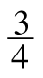 or 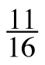? How can you be sure?

1-22. Find the perimeter and area of each figure below.
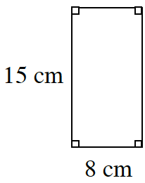
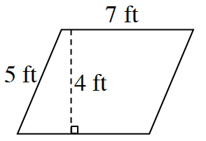
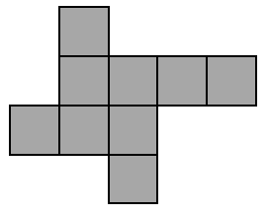
a. b. c.

Area: __________________ Area: _____________________ Area: ___________________

Perimeter: _____________ Perimeter: ________________ Perimeter: ______________

